|  |
| --- |
|  |
| JUNOS Profile Builder  Network Support Tool designed for FiOS subscribers with service on Juniper MX routers. |
| |  |  |  | | --- | --- | --- | | Hiramoto, Robert | 5/26/17 | Frontier Communications | |

Table of Contents

Purpose2

Requirements3

How to launch application

* Juniper_Profile_Builder_v1.04

How to use Application

* MX Dynamic6
* MX VoIP7
* MX Static IN/OR/WA Serviceman8
* MX Static CA/TX/FL9

**Purpose**

The Internet has become the most important service for our subscribers and it is our responsibility to ensure that our customers have mimimal downtime to satisfy our service level agreements. The purpose of this application is to make it easier to support Frontier’s FiOS residential and business subscribers. To achieve this goal, I have built an application using Python that will automatically build any subscriber’s profile in an MX series router.

Some of the major users for this application will include the following:

* Residential field technicians
* Business field technicians
* Network technicians
* Special Operations Technicians (SPOT)
* Triad Operations
* Network Operations Center

I am confident that this application will save the company millions of dollars since it will make it easier for agents in Network Support to build these gateway router profiles.

Many agents do not have the knowledge of how to build these Juniper profiles since most of the MX equipment came over in the VZ3 acquisition. This application accomplishes the following:

* Saves the time of having to figure out which router to access
* Saves the time of manually logging into the router
* Saves the time of looking up on a Word/Excel document how the profile should be built
* Saves the time of manually building the profile
* Saves field technicians time to call into the NT line.
* Saves NTs from having to escalate these type of issues to SPOT
* Saves SPOT from having to call the NOC.

This application will reduce user error and can be used for auditing purposes to see if a subscriber’s circuit that is not working was built correctly to begin with by using a “Kill and Build” approach.

**Requirements:**

The following hardware and software is required to launch and run the application. The software has been compiled and is ready to be launched as an executable.

**Hardware Requirements:**

* Windows PC running Windows 7 operating system or newer.
* Dual core Processor or newer
* At least 4 GB of RAM installed
* At least 16 GB of free Hard Drive space

**Software and Library Requirements:**

* **Python 3.5** - Python is an easy to learn, powerful programming language. It has efficient high-level data structures and a simple but effective approach to object-oriented programming. Python’s elegant syntax and dynamic typing, together with its interpreted nature, make it an ideal language for scripting and rapid application development in many areas on most platforms.
* **Pywinauto** - is a GUI automation library written in pure Python and well developed for Windows GUI. At its simplest it allows you to send mouse and keyboard actions to dialogs and controls on both Windows and Linux, while more complex text-based actions are supported on Windows only so far.
* **Netmiko 1.4.0** – The Netmiko library is based on the Paramiko SSH library. Netmiko can successfully establish an SSH connection to a Juniper Junos device. It allows the execution of show commands and the retrieval of output data.
* **JUNOS_profile_builder_v1.0.py** – software developed in Python to automatically build Juniper JUNOS MX profiles after a user enters a set of parameters into the custom GUI.

**How to Launch Application**

**JUNOS_Profile_Builder_v1.0:**

To launch this program, you can just double click on the executable file entitled “JUNOS_Profile_Builder_v1.0.exe”. It has already been compiled and all of the associated libraries have been added.

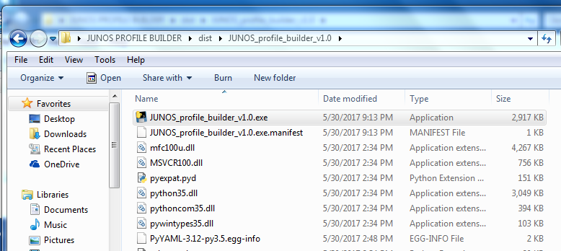

You can also create a shortcut to the executable file and save it on your Desktop. The easiest way to do this is right-click on the .exe file and select “Send To” and Create Shortcut



Once JUNOS_Profile_Builder_v1.0.exe has been launched successfully, you will see a GUI screen like the screenshot below:

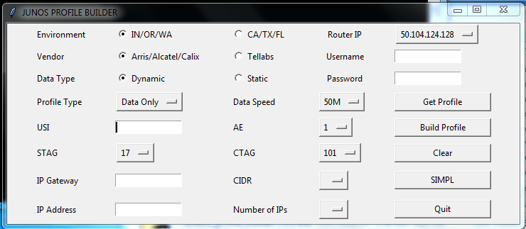

**How to use Application**

PLEASE make sure that you are extremely careful when selecting your parameters. Always double-check that all of the information that you populated or selected in the GUI is correct before clicking the “Build Profile” button. For faster scrolling through the dropdowns, please use the **UP** arrow and **DOWN** arrow on your keyboard. Also, please make sure that you are extremely careful which Router IP you are accessing so that you don’t build a profile in the wrong MX router. Make sure that you are using a CORP username and password that has “**write**” access.

**MX Dynamic (IN/OR/WA or CA/TX/FL)**

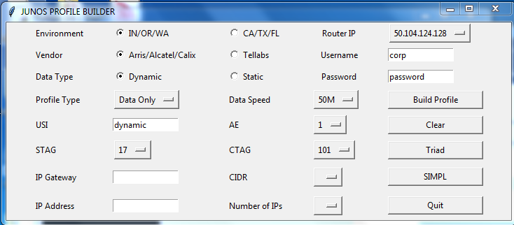

1. Choose your Environment **(IN/OR/WA or CA/TX/FL)**
2. Choose your Vendor **(Arris/Alcatel/Calix or Tellabs)**
3. Choose your Data Type **(Dynamic)**
4. Choose your Profile Type **(Data Only, Data Video, Video Only)**
5. Choose your Data Speed **(5M to 1000M)**
6. Enter your subscriber’s USI **(i.e. 370012345678)**
7. Choose your AE – **(i.e. 26)**
8. Choose your STAG – not needed for Tellabs vendor **(i.e. 41)**
9. Choose your CTAG – **(i.e. 101)**
10. Choose your Router IP address **(i.e. 50.104.124.128)**
11. Enter your Username and Password **(Please make sure that you have “write” privileges)**
12. Click the “**Build Profile**” button

**MX VoIP (IN/OR/WA or CA/TX/FL)**

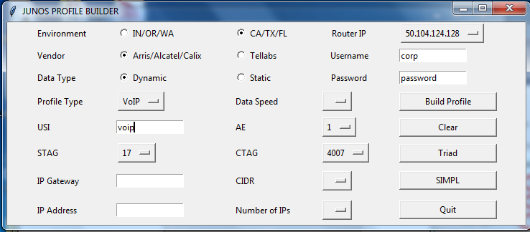

1. Choose your Environment **(IN/OR/WA or CA/TX/FL)**
2. Choose your Vendor **(Arris/Alcatel/Calix or Tellabs)**
3. Choose your Data Type **(Dynamic)**
4. Choose your Profile Type **(VoIP)**
5. Enter your subscriber’s USI **(i.e. 370012345678)**
6. Choose your AE – **(i.e. 26)**
7. Choose your STAG – not needed for Tellabs vendor **(i.e. 41)**
8. Choose your CTAG – **(i.e. 101)**
9. Choose your Router IP address **(i.e. 50.104.124.128)**
10. Enter your Username and Password **(Please make sure that you have “write” privileges)**
11. Click the “**Build Profile**” button

**MX Static IN/OR/WA (Serviceman)**

To provision a Static IP in the IOW areas, please populate the **IP GATEWAY and CIDR** fields only.The other Static fields are not used and entering data for those is unnecessary.

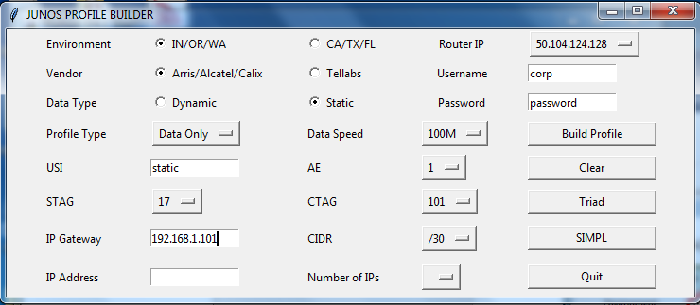

1. Choose your Environment (**IN/OR/WA**)
2. Choose your Vendor **(Arris/Alcatel/Calix or Tellabs)**
3. Choose your Data Type **(Static)**
4. Choose your Profile Type **(Data Only or Data Video)**
5. Choose your Data Speed **(5M to 1000M)**
6. Enter your subscriber’s USI **(i.e. 370012345678)**
7. Choose your Interface – **(i.e. 2)**
8. Choose your STAG – not needed for Tellabs **(i.e. 17)**
9. Choose your CTAG – **(i.e. 101)**
10. Enter your IP Gateway **(i.e. 192.168.1.101)**
11. Choose your CIDR **(i.e. /30 for 1 IP address)**
12. Choose your Router IP address **(i.e. 50.104.124.128)**
13. Enter your Username and Password **(Please make sure that you have “write” privileges)**
14. Click the “**Build Profile**” button

**MX Static CA/TX/FL**

To provision a Static IP in the CTF areas, please populate the **IP ADDRESS and NUMBER OF IPS** fields only. The other Static fields are not used and entering data for those is unnecessary.

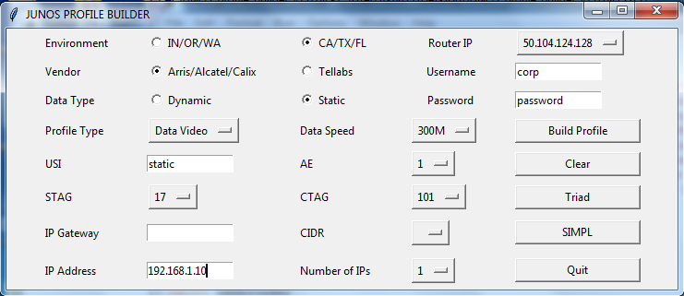

1. Choose your Environment (**CA/TX/FL**)
2. Choose your Vendor **(Arris/Alcatel/Calix or Tellabs)**
3. Choose your Data Type **(Static)**
4. Choose your Profile Type **(Data Only or Data Video)**
5. Choose your Data Speed **(5M to 1000M)**
6. Enter your subscriber’s USI **(i.e. 570012345678)**
7. Choose your AE – **(i.e. 2)**
8. Choose your STAG – not needed for Tellabs **(i.e. 41)**
9. Choose your CTAG – **(i.e. 101)**
10. Enter your IP Address **(i.e. 192.168.1.100)**
11. Choose the number of IPs you would like built (i.e. 5)
12. Choose your Router IP address **(i.e. 50.104.124.128)**
13. Enter your Username and Password **(Please make sure that you have “write” privileges)**
14. Click the “**Build Profile**” button